AWS LAMBDA
AWS Lambda is a compute service that runs code without the need to manage servers. Your code runs, scaling up and down automatically, with pay-per-use pricing.
Create a Lambda function that returns a simple JSON response.
- Open Lambda in AWS console
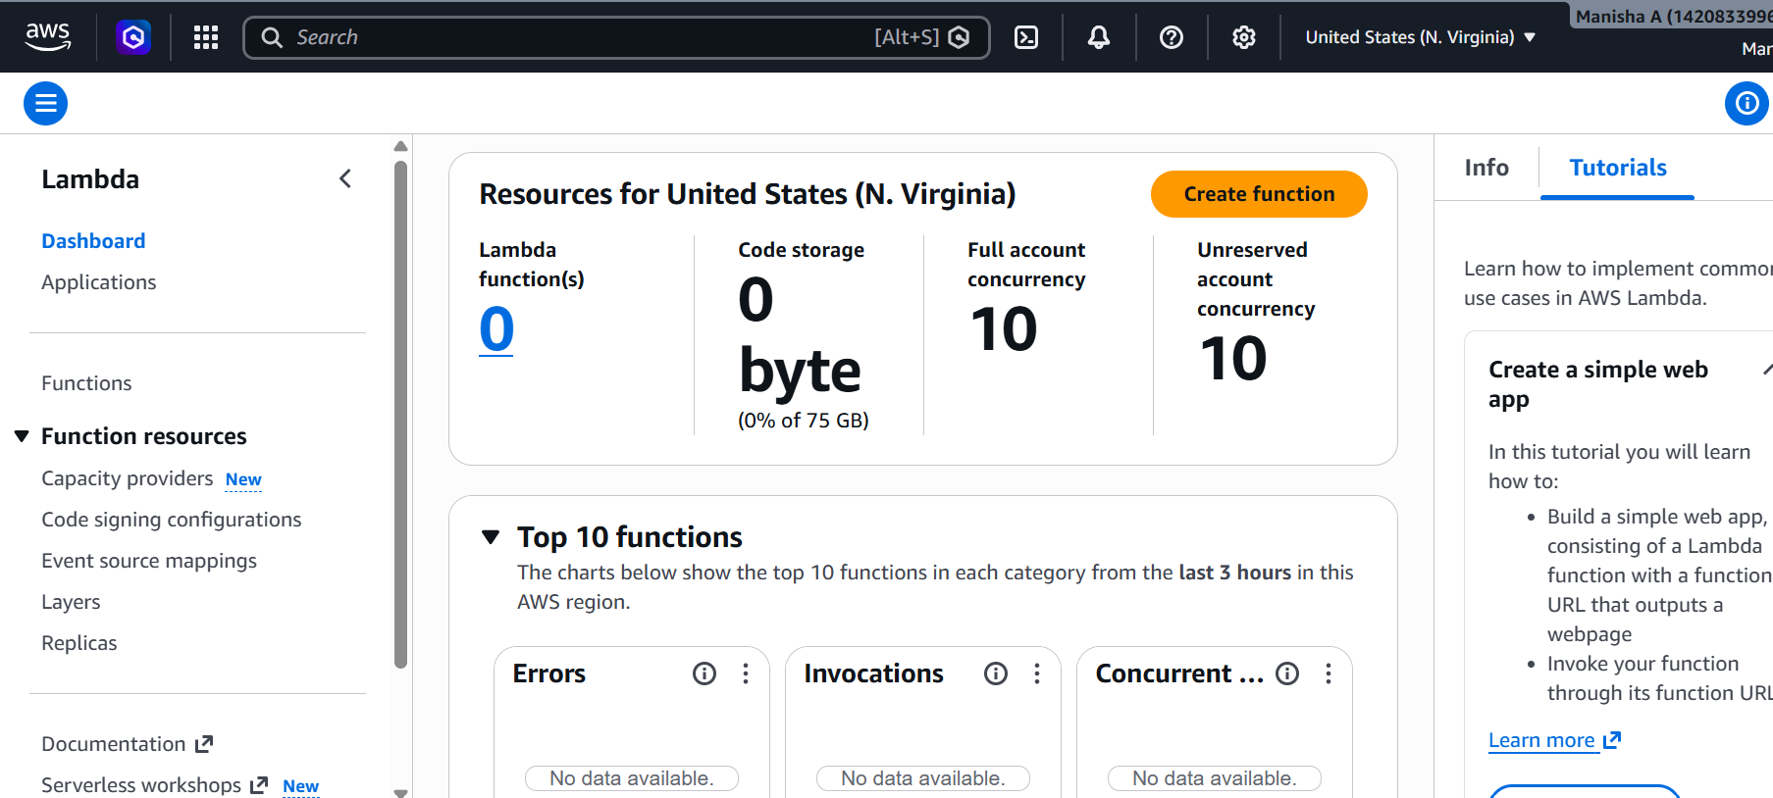
Create Lambda Function
Click on create function Select Author from scratch Function Name Choose Runtime Architecture Click Create Function
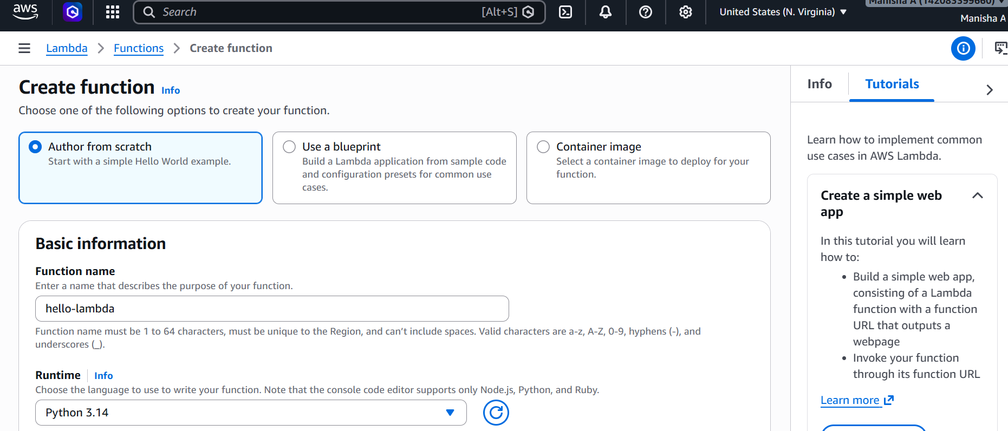
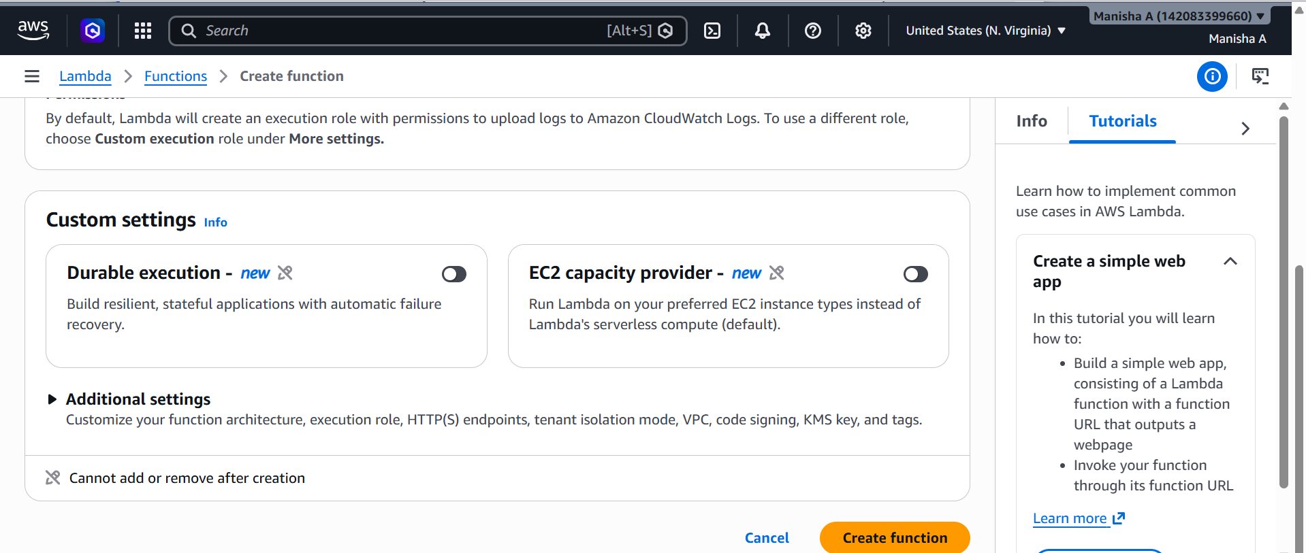
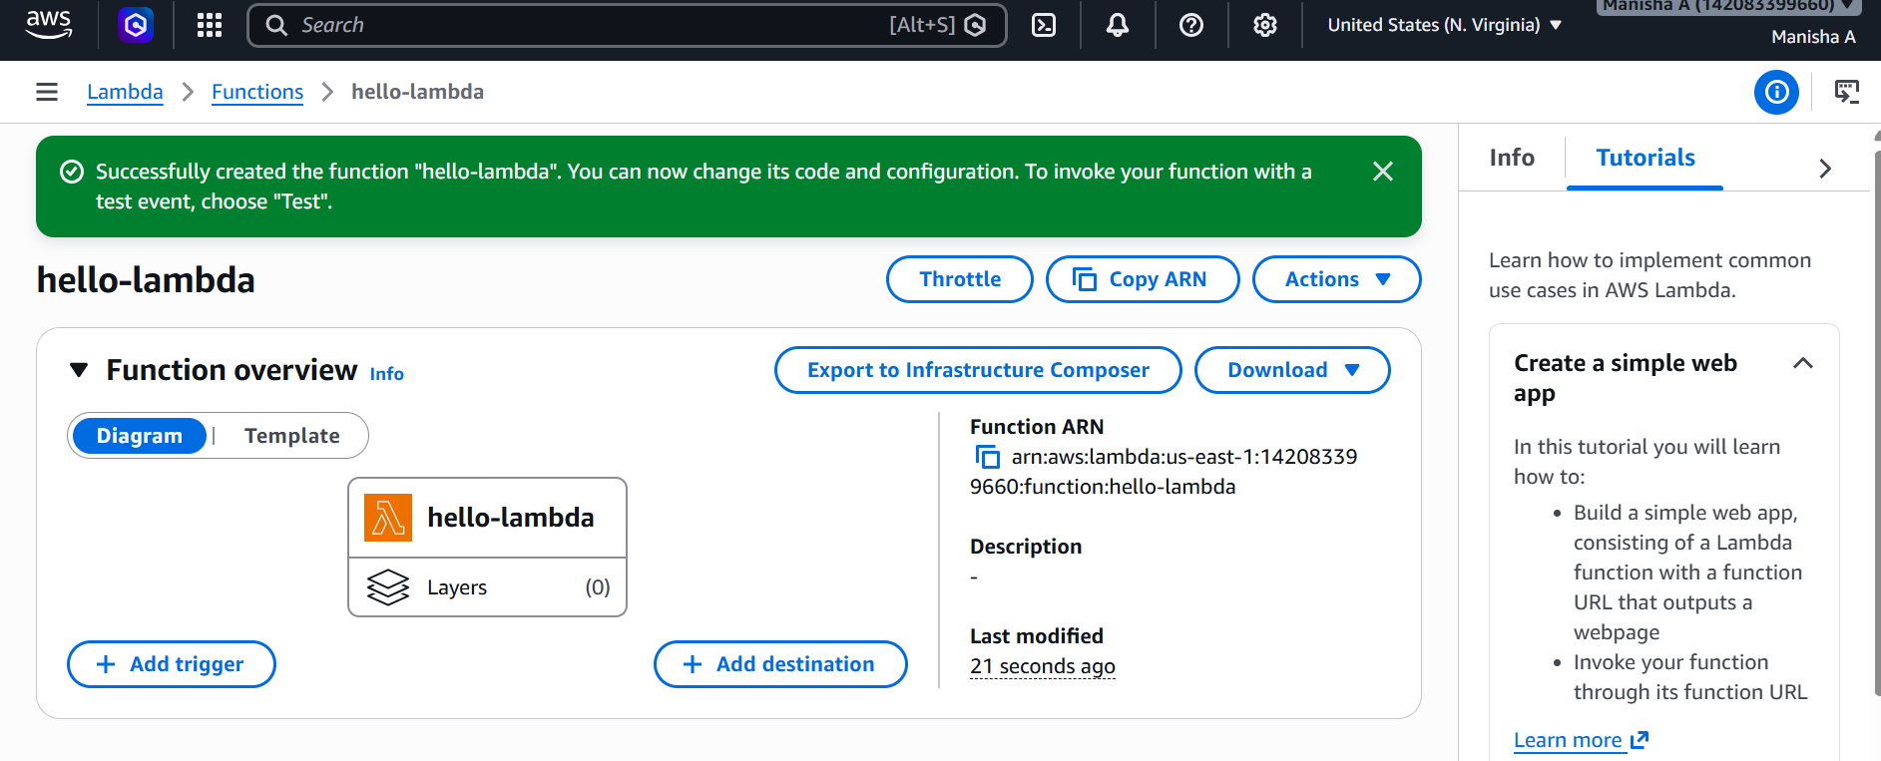

- Add Lambda code and click on deploy
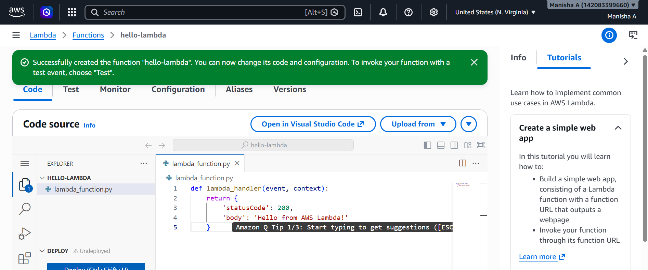
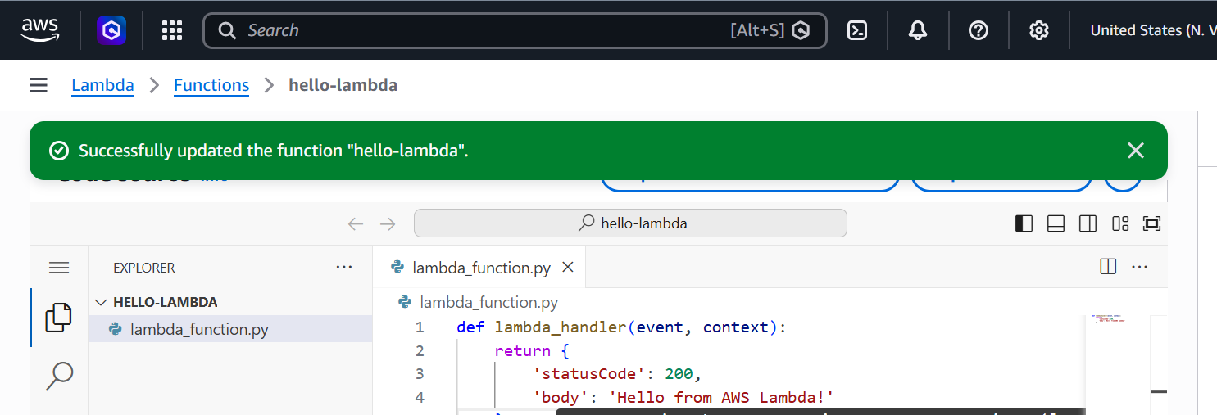
Test Lambda Function
Click test -create test event
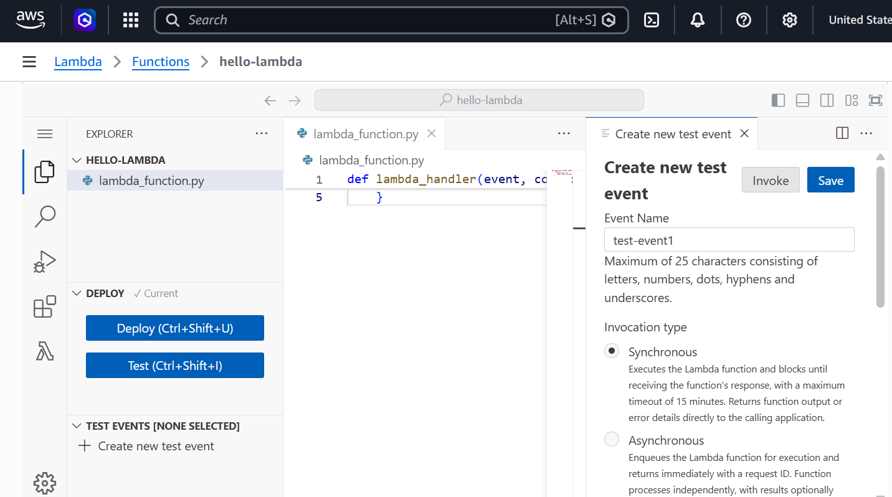
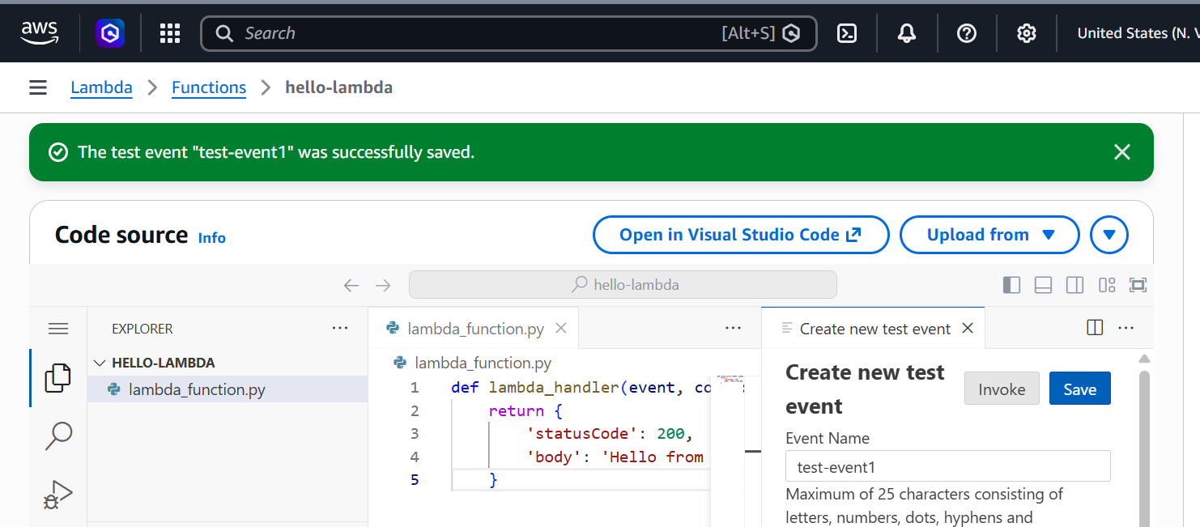
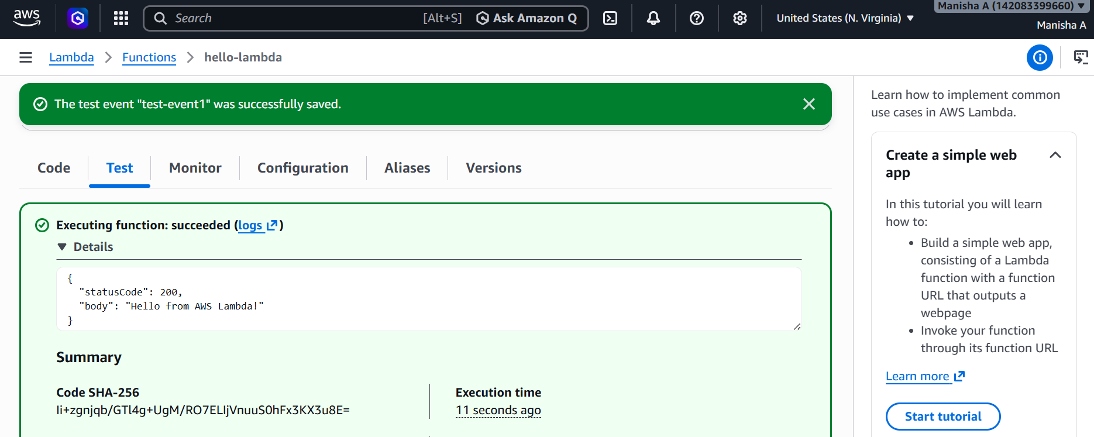
Use Case : Create an AWS Lambda function that automatically runs whenever a file is uploaded to an S3 bucket and prints the uploaded file name in CloudWatch Logs.
- First lets create an S3 bucket
Click Create Bucket Bucket Name Click Create Bucket
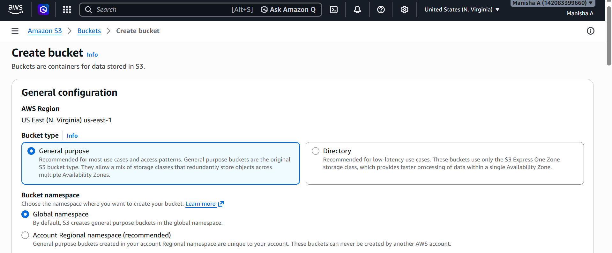
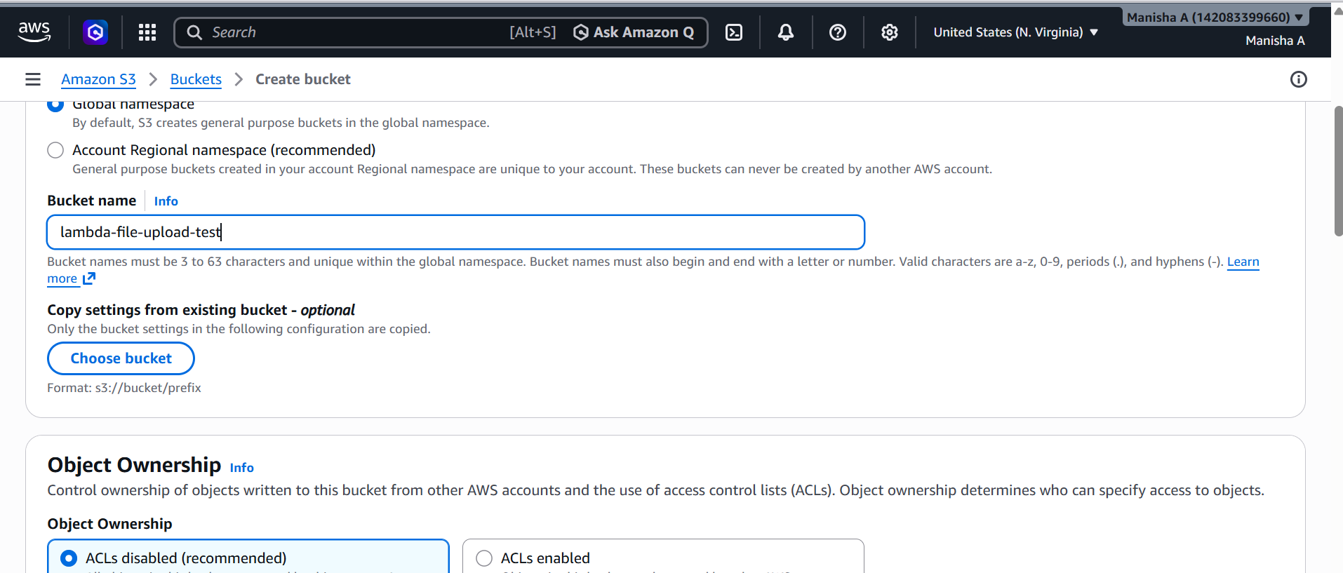
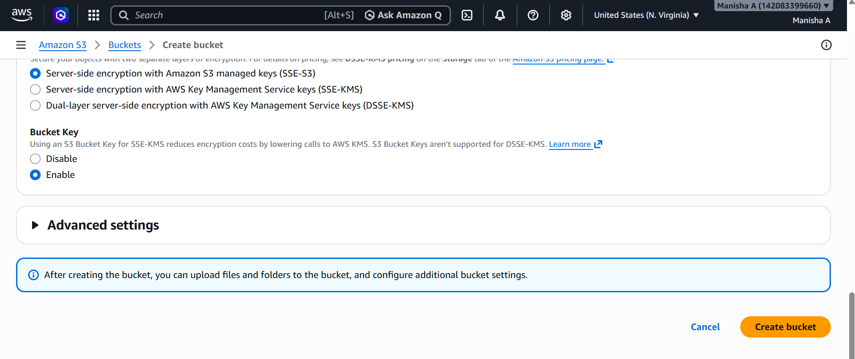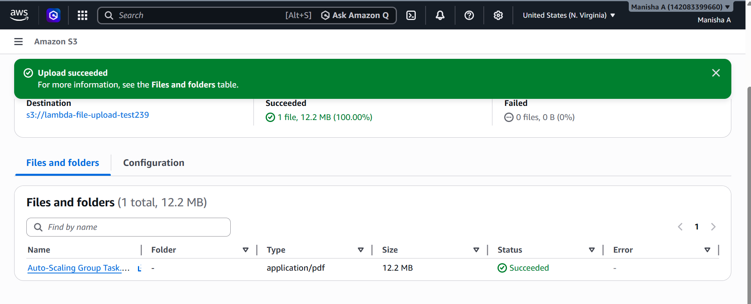
- Create Lambda Function
Click Create Function Select Author from scratch give Function Name Choose runtime Click Create Function
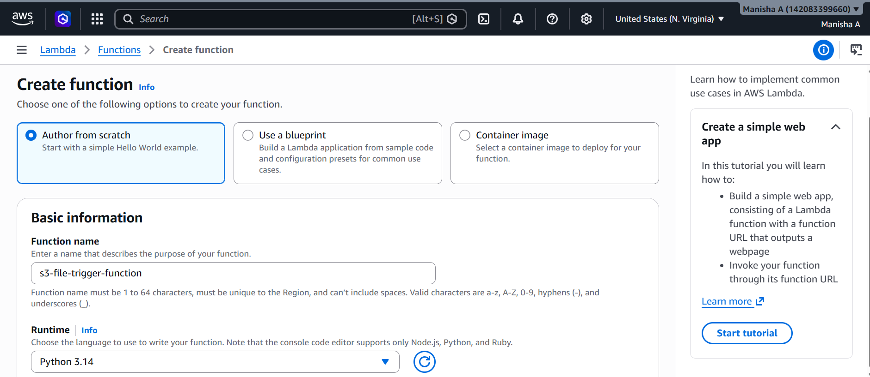
Add lambda code and deploy
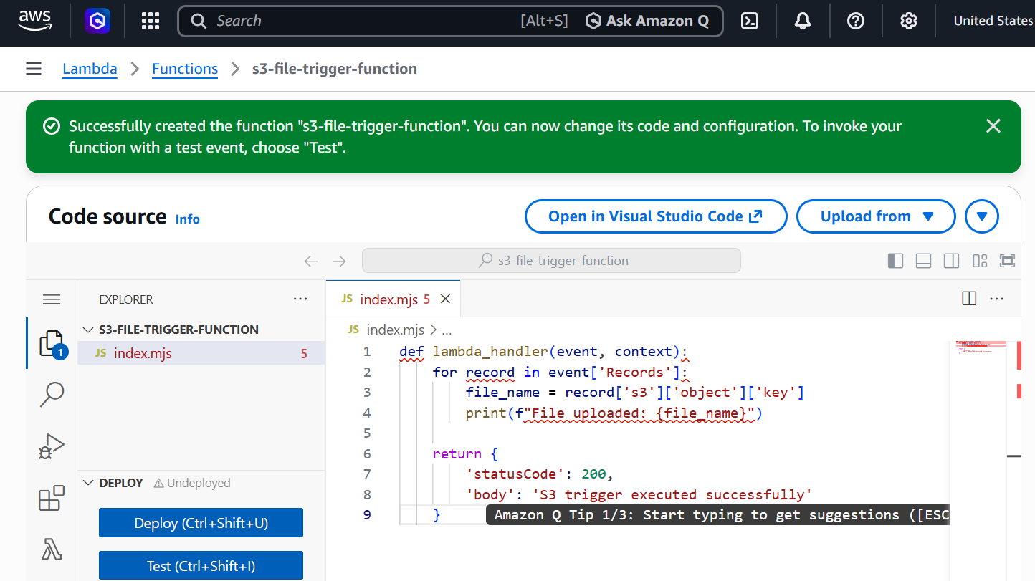
Add S3 Trigger
Click Add Trigger Select source: S3 Choose bucket Event type: PUT (Object Created) Enable trigger Click Add

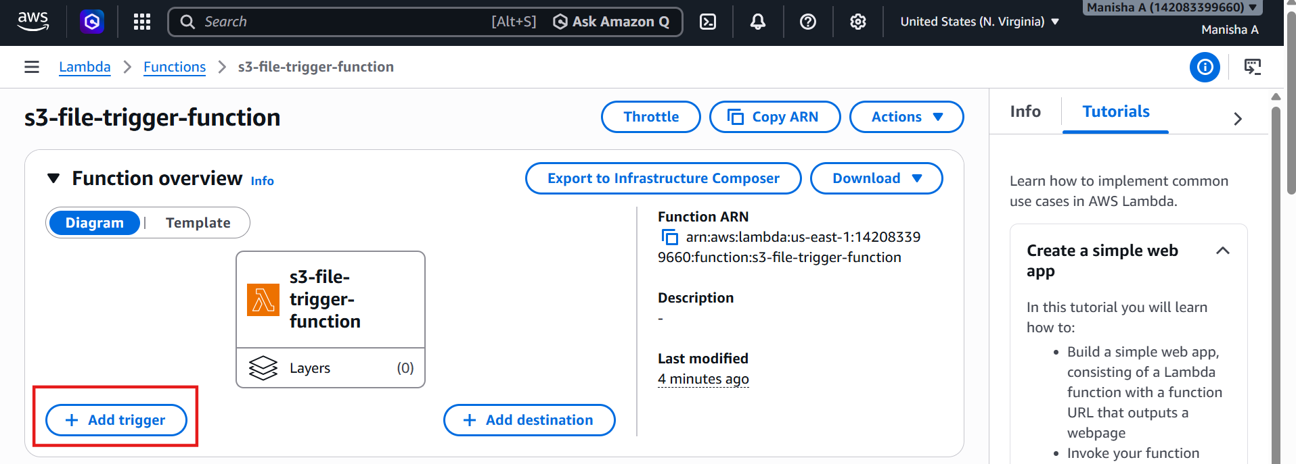

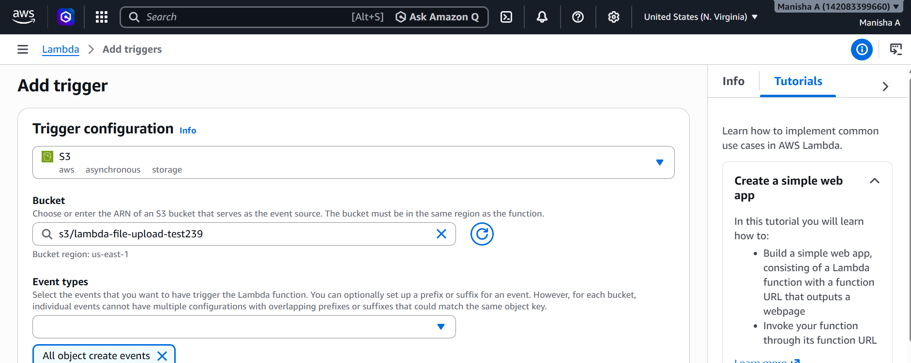

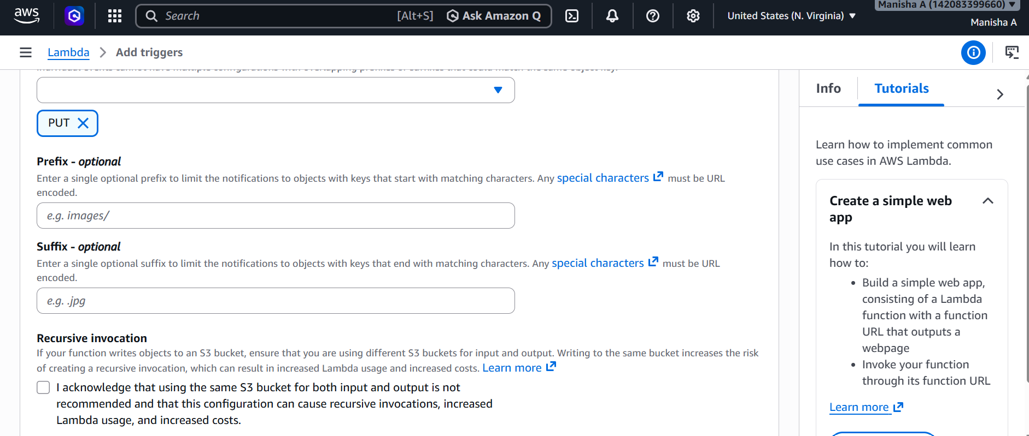
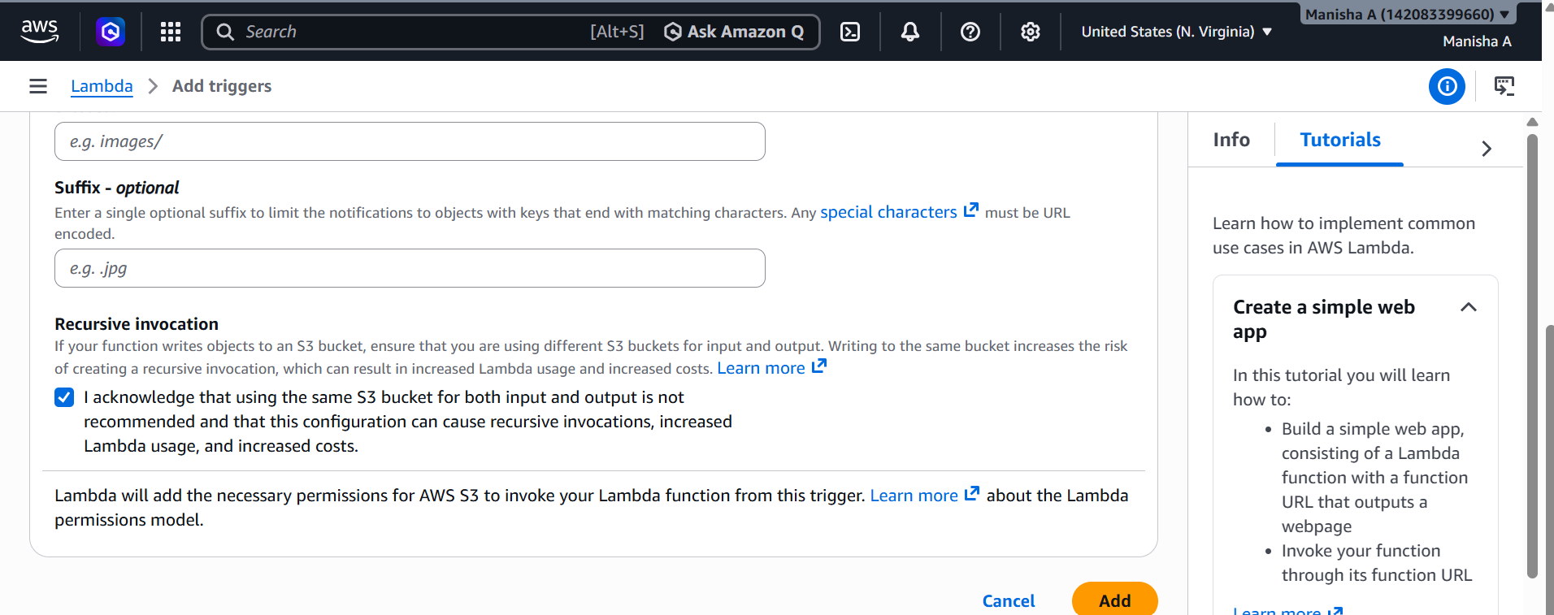
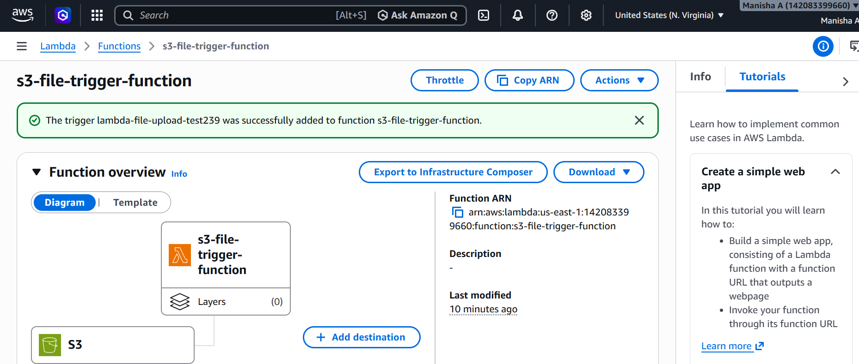
Upload file in S3 bucket
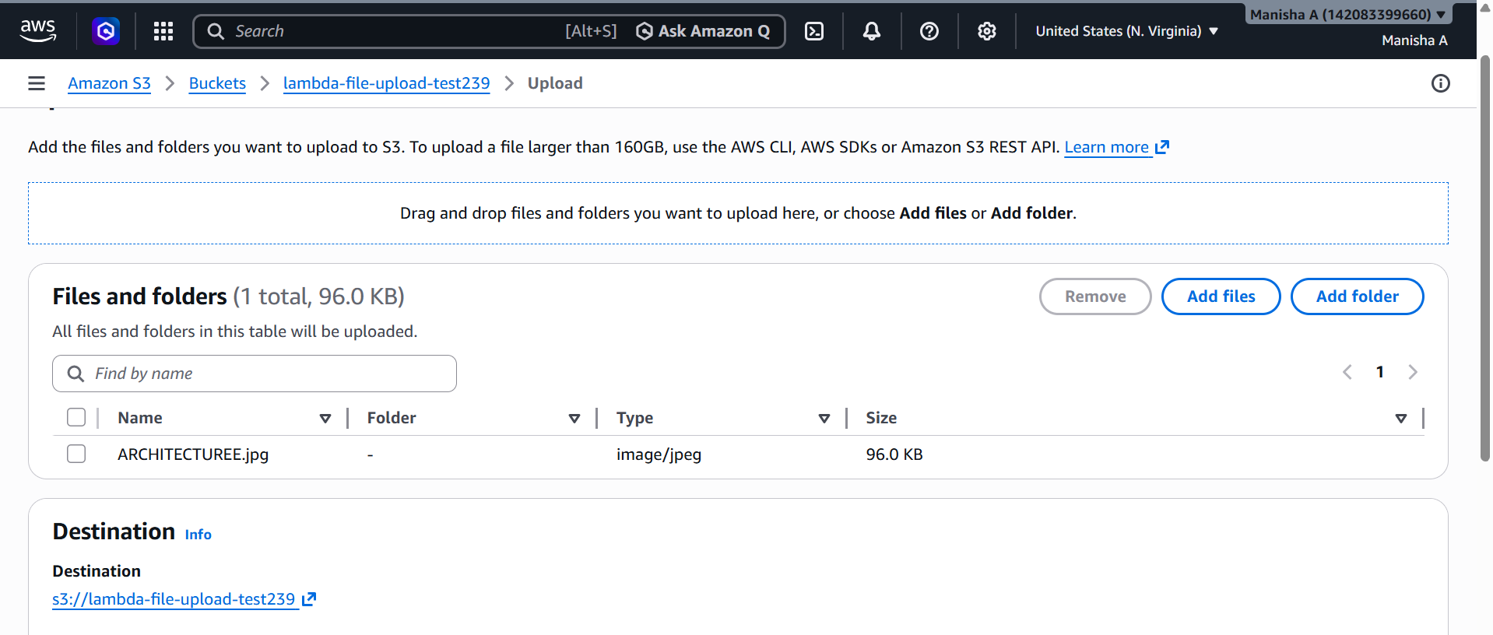
Go to aws lambda click on monitor view cloudwatch logs
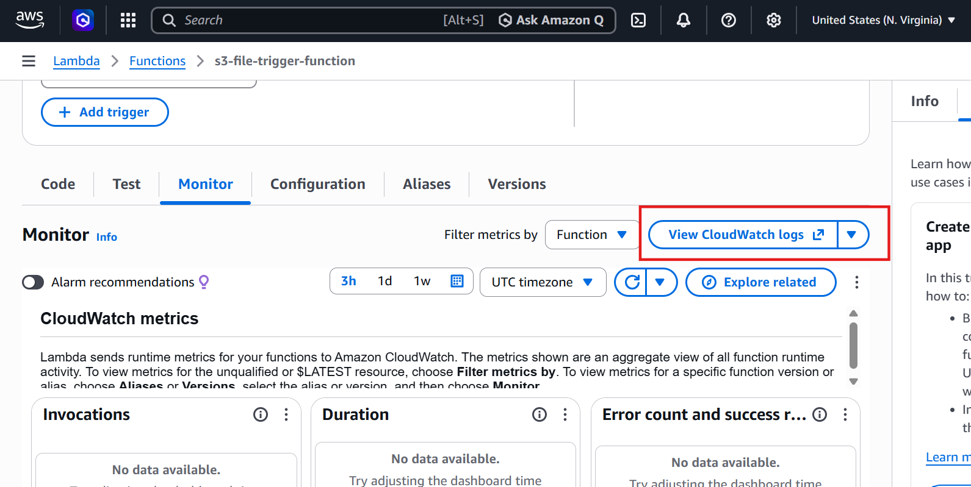
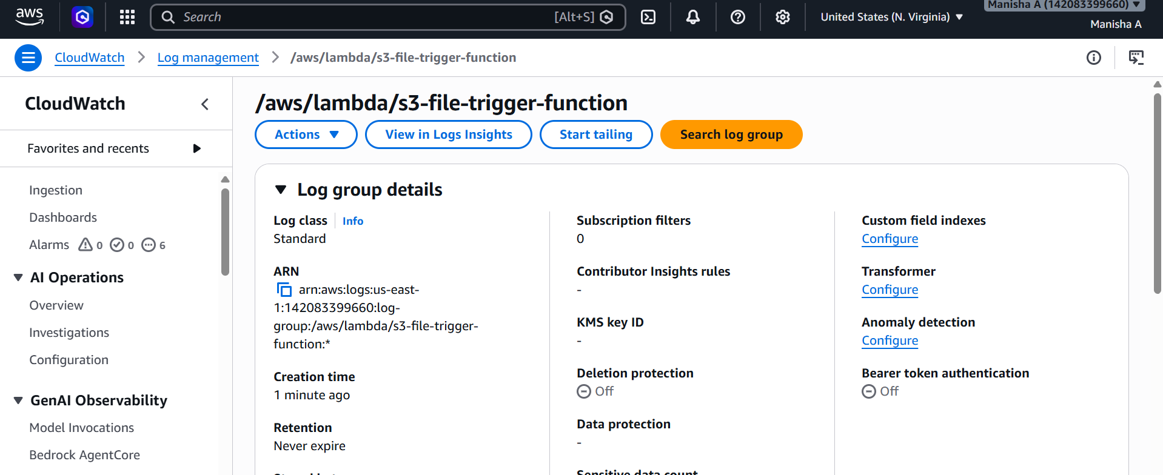
Here we are able to see the log of uploaded file
